<https://www.youtube.com/watch?v=fLw8SfvaJWA&list=PLwdnzlV3ogoXaceHrrFVZCJKbm_laSHcH&index=3>

<https://www.youtube.com/watch?v=E5jVBqe59EE>

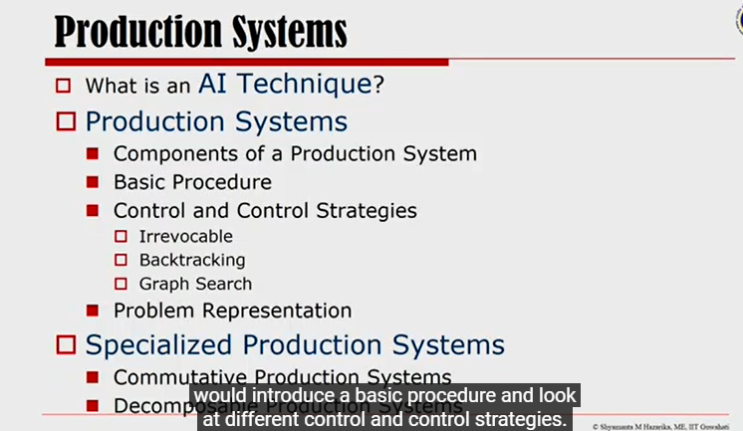

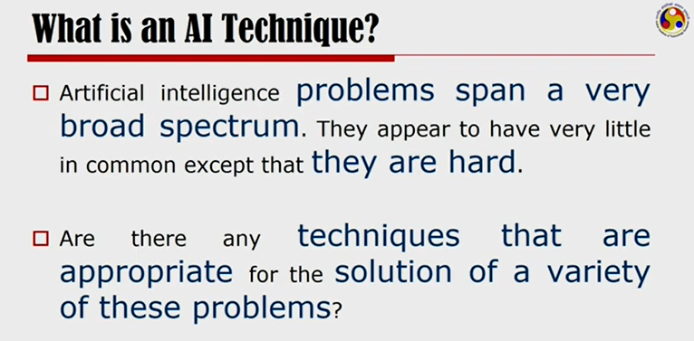

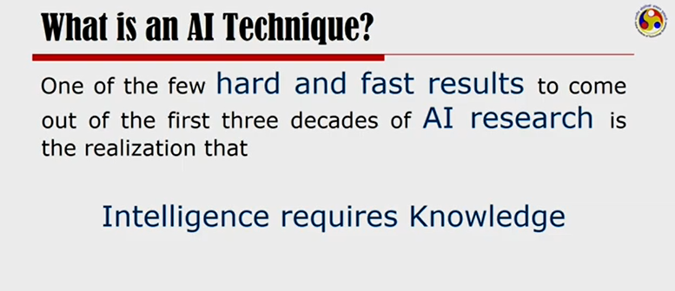

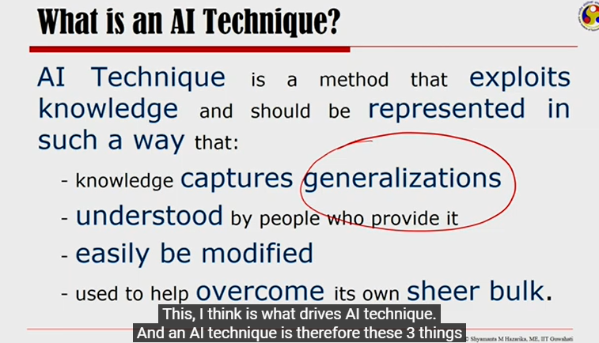

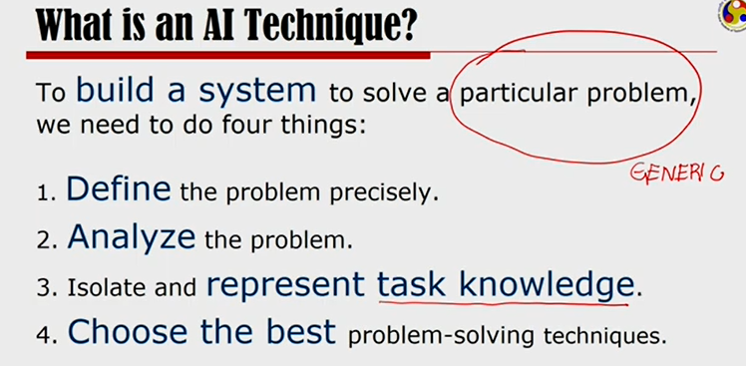

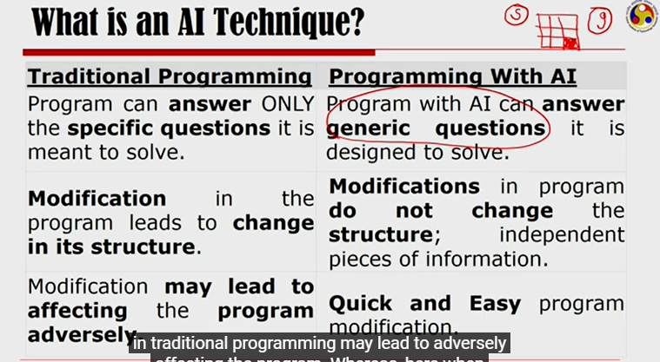

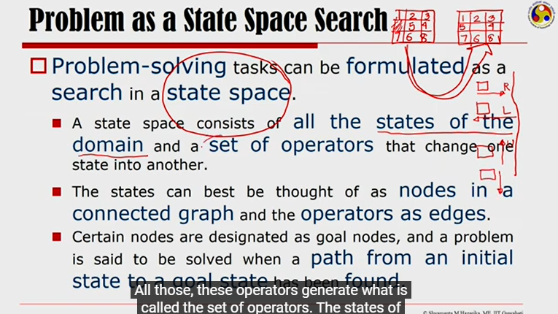

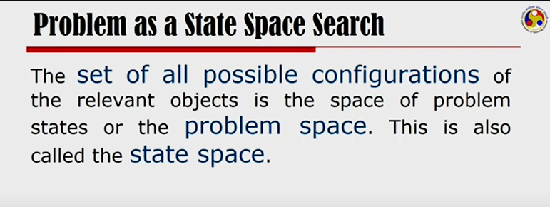

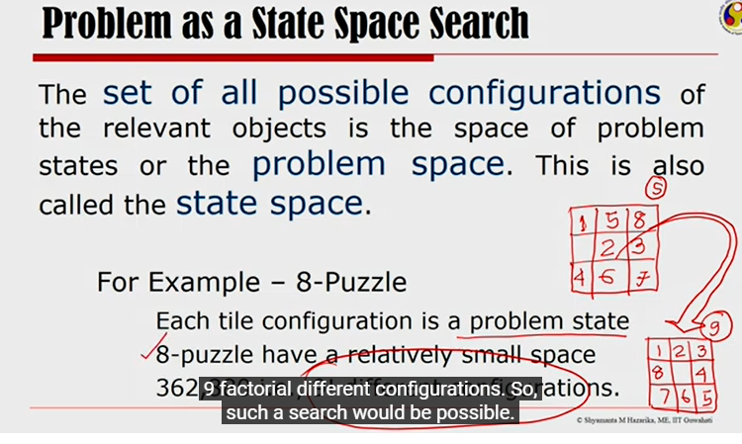

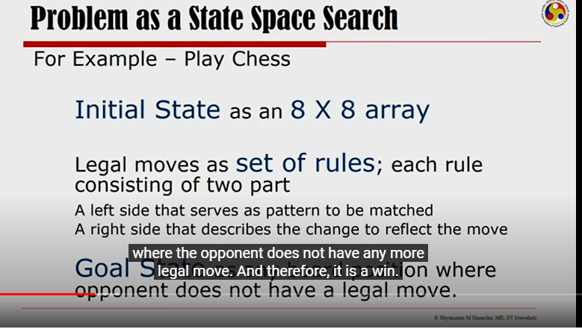

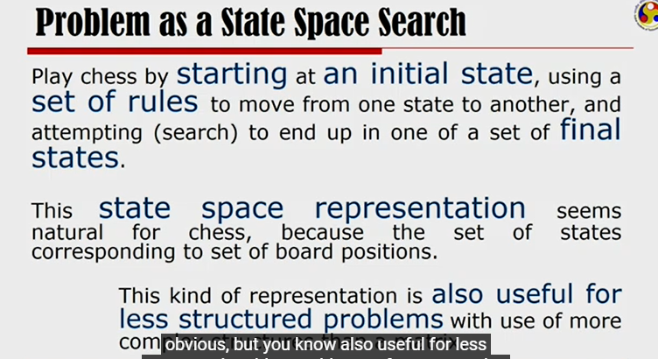

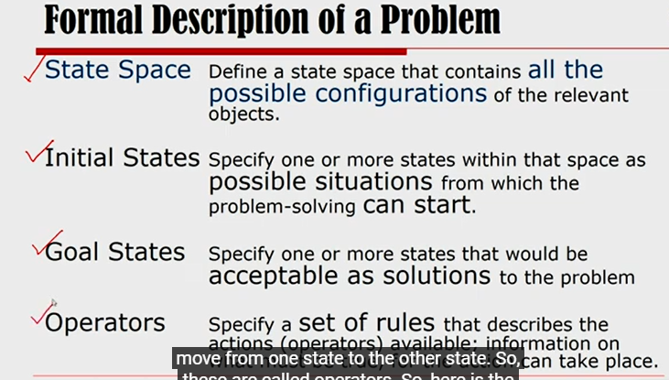

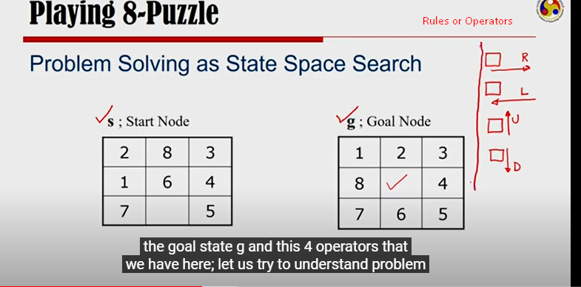

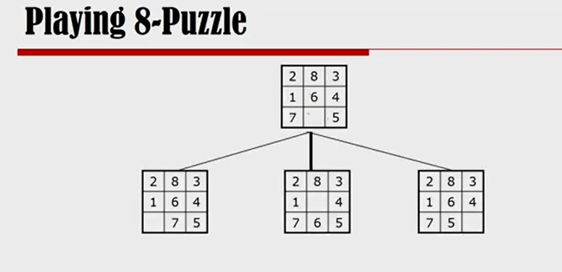

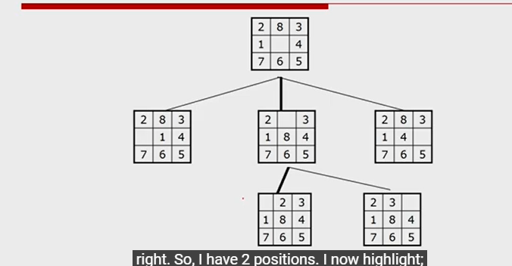

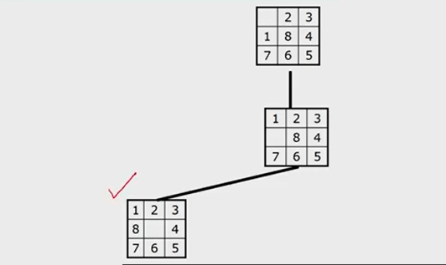

This kind of paradigm of problem solving is called ‘State Space Search’. All possible configurations is called a State Space. All possible actions that you can take are called Rules/Operators. Here, you can move an empty tile to the right or left or up or down. Those are the rules.

You have to feed Start State, End State and Rules to solve a problem using State Space Search.

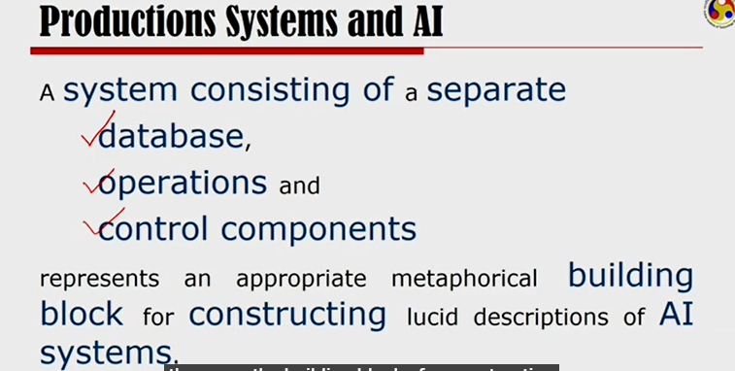

Productions means Rules.

Database means a set of Rules (database of rules).

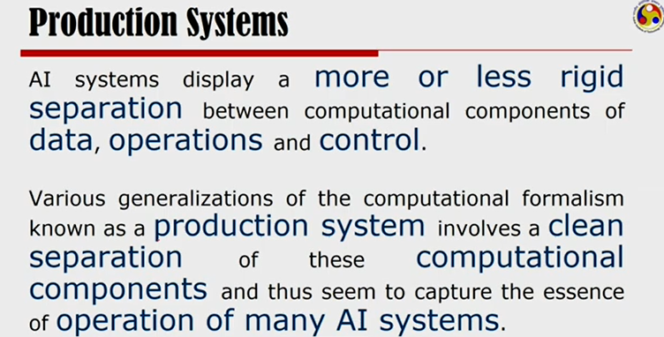

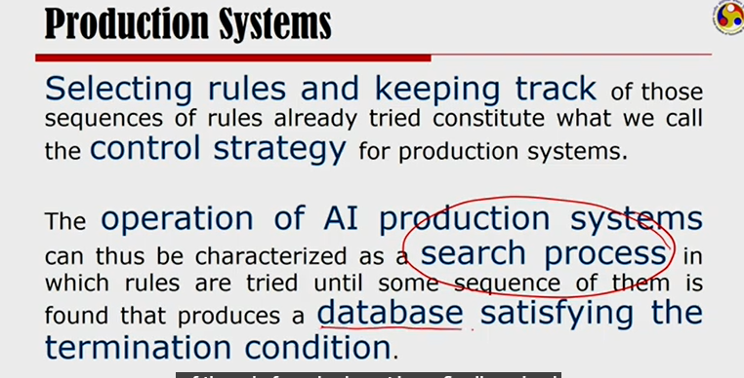

Selecting rules and keeping track of the sequences of the rules that are already tried is called Control Strategy.

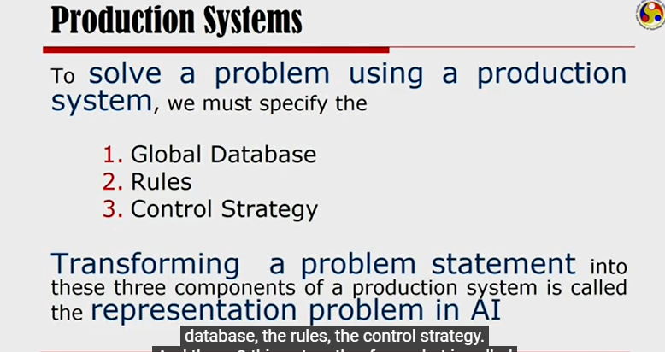

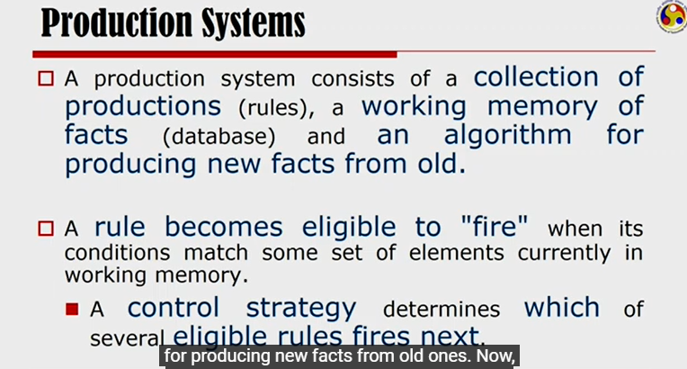

<https://www.youtube.com/watch?v=Aebkfuqj1Og>

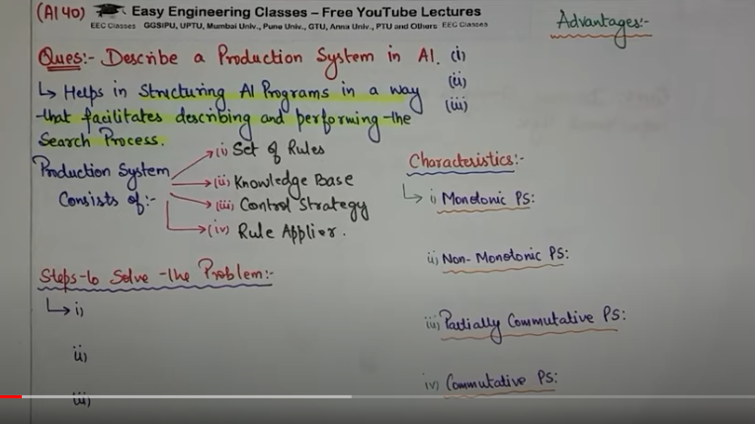

Production System helps in structuring AI programs in a way that facilitates describing and performing the Search Process.

It consists of 4 components

* Set of rules
* Knowledge Base/Database where these rules are stored
* Control strategy – order in which rules should be compared with db, so that conflicts can be resolved in minimum time.
* Rule Applier – Based on control strategy, it applies the rules

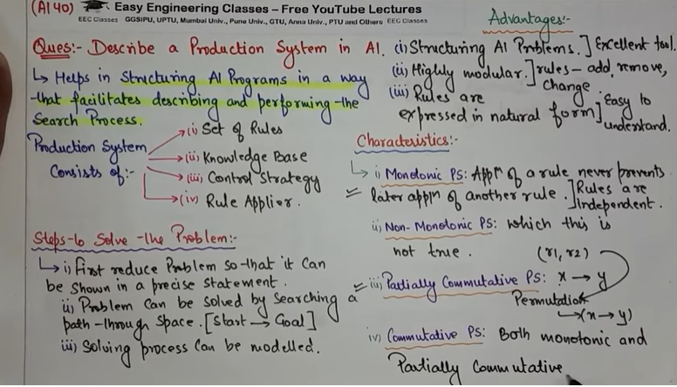

Monotonic Production System – Application of one rule does not prevent the application of another rule. Rules are independent of each other. One Rule doesn’t affect another rule.

Partially Commutative Production System – application of different rules in different orders will you take you to the same state x to y.

Commutative Production System - Monotonic + Partially Commutative

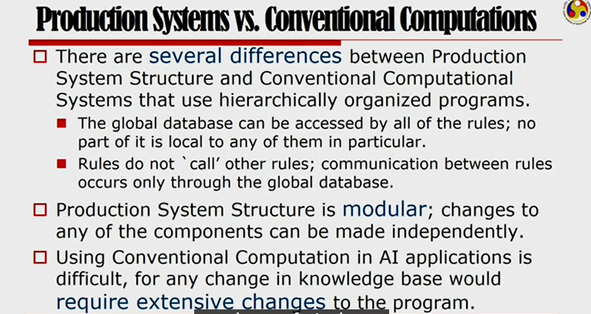

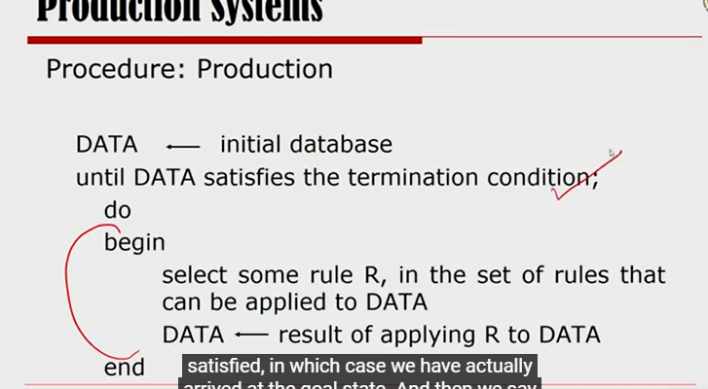

Keep doing this until we arrived at goal state.

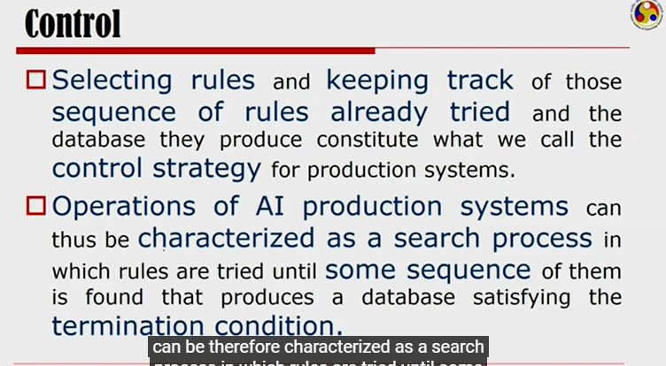

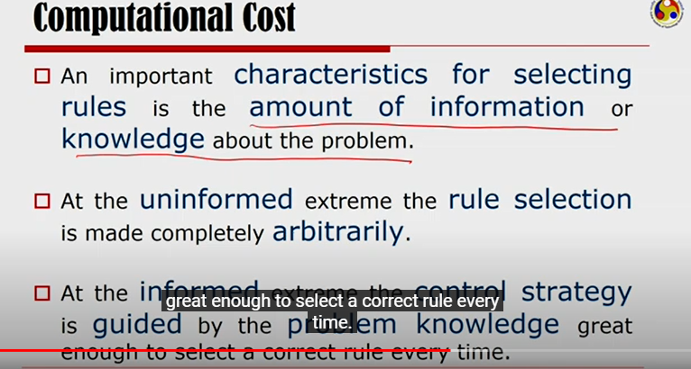

Uninformed vs Informed search.

When you don’t know much about the problem, you have to keep applying random rules and at some point, you will reach to the goal state.

When you know the most about the problem, you can apply a correct sequence of problem that reduces the total cost of finding the goal state.

<https://www.youtube.com/watch?v=gZpUcsB9TFc>